S-401 Notice Marks Proof of Concept
Can’t use the Hover drawing instruction as defined by the S-100 Portrayal specification due to the following:
- The Hover instruction specifies additional drawing instructions that are executed when the user hovers over a feature. It cannot turn off drawing instructions, meaning that the single Notice Mark stays visible when showing the fanned out Notice Marks.
- Even if the Portrayal did allow that functionality, implementation of the Hover instruction is OEM optional.
This leaves defining a new Context Parameter as the obvious solution.
The screenshots shown were created with S100Viewer 2.1 using the jmassey_NoticeMark branch of the Portrayal Catalogue.
IMPORTANT: S100Viewer and ShoreECDIS both require version 2.1 or later to work correctly with this Portrayal Catalogue branch. The common library used by both products did not implement the LocalCRS for augmented points. This is presumably the first portrayal to use that feature so it’s possible other implementations may not support LocalCRS augmented points.
The test data set is located at https://github.com/IEHG/Test-cells/blob/main/401003T7TEST1_000.000.
The feature catalogue is located at https://github.com/IEHG/Feature-Catalogue/blob/main/S-401%20Feature%20Catalogue%20edition%201.3.0.xml.
The portrayal catalogue is located at https://github.com/IEHG/Portrayal-Catalogue/tree/jmassey_NoticeMark.

The first portrayal displayed is with the Fan out Notice Marks context parameter set to off. The number 6 in the lower right corner indicates how many Notice Marks are co-located at the same point.
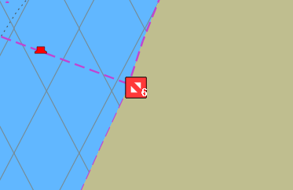
The second portrayal displayed is with the Fan out Notice Marks context parameter set to on. The portrayal fans all of the Notice Marks evenly.
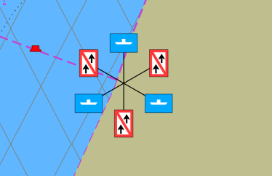

Work To Be Done
Determine how to display the number of co-located Notice Marks. Currently this is done with a text instruction.
Determine what symbol to display indicate multiple Notice Marks are at a common location.

